Senior Project Fall 2021 Notes:

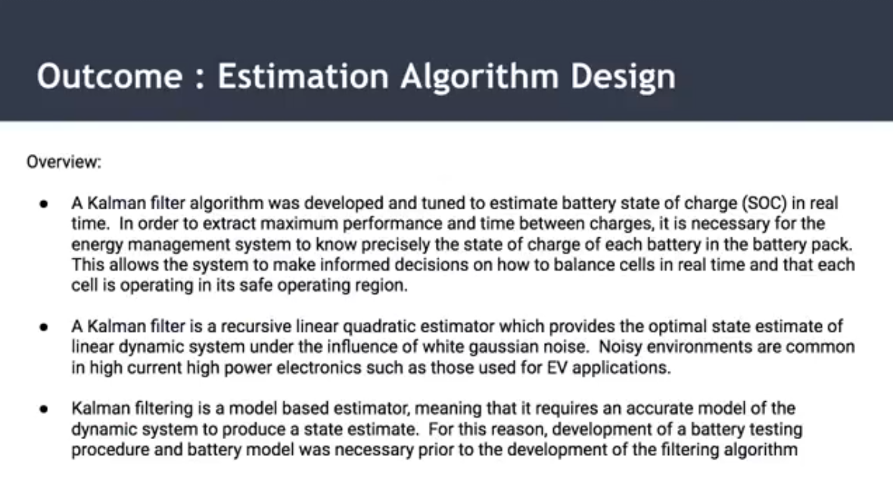

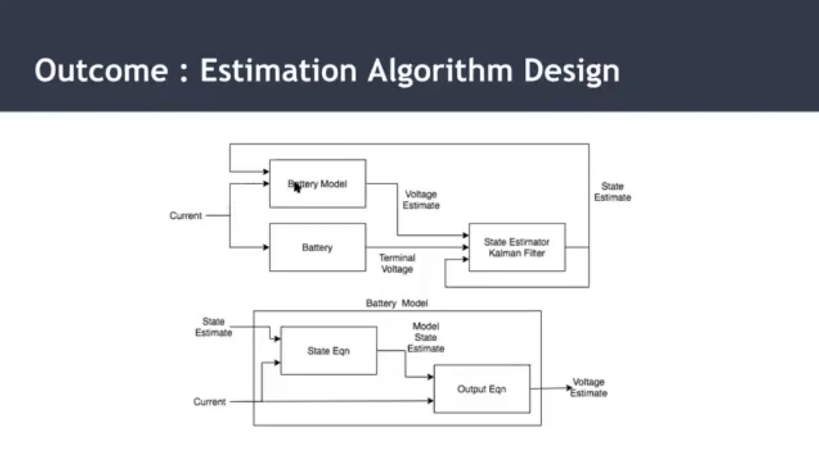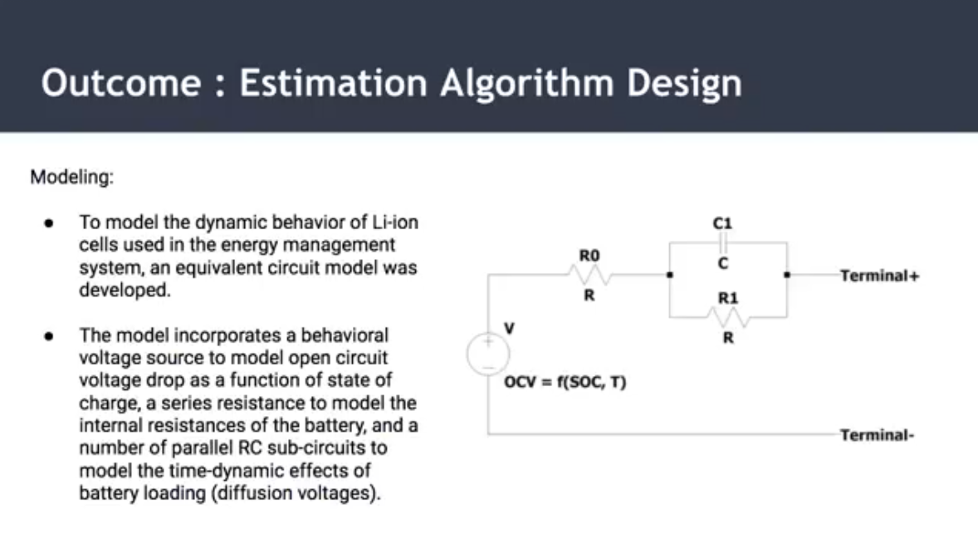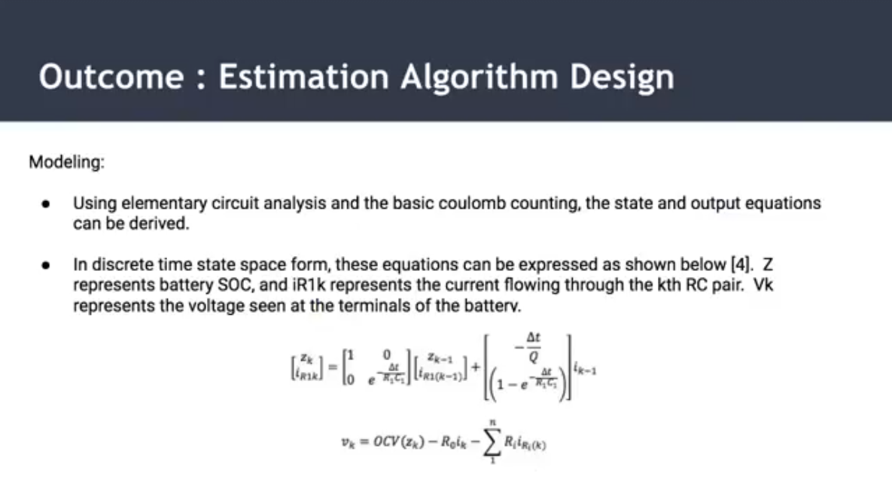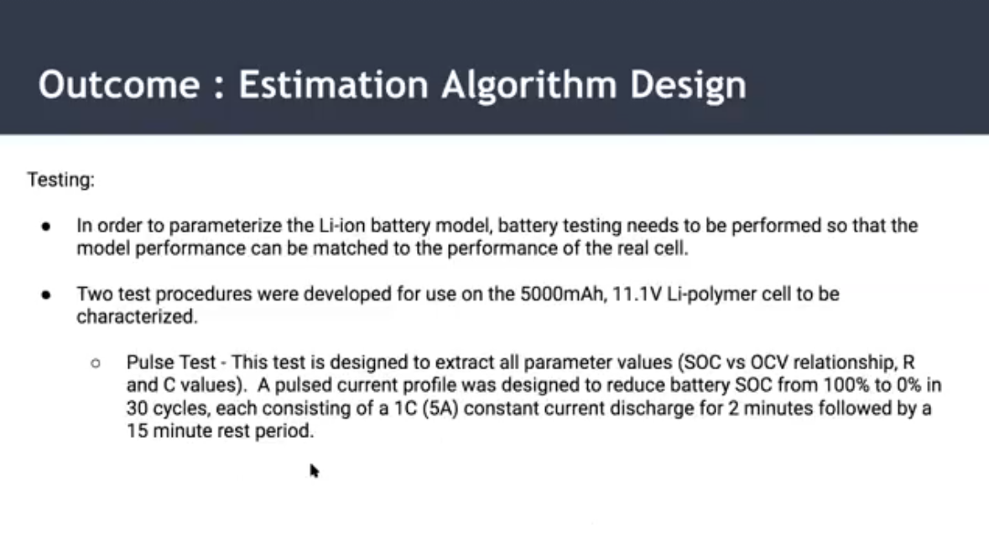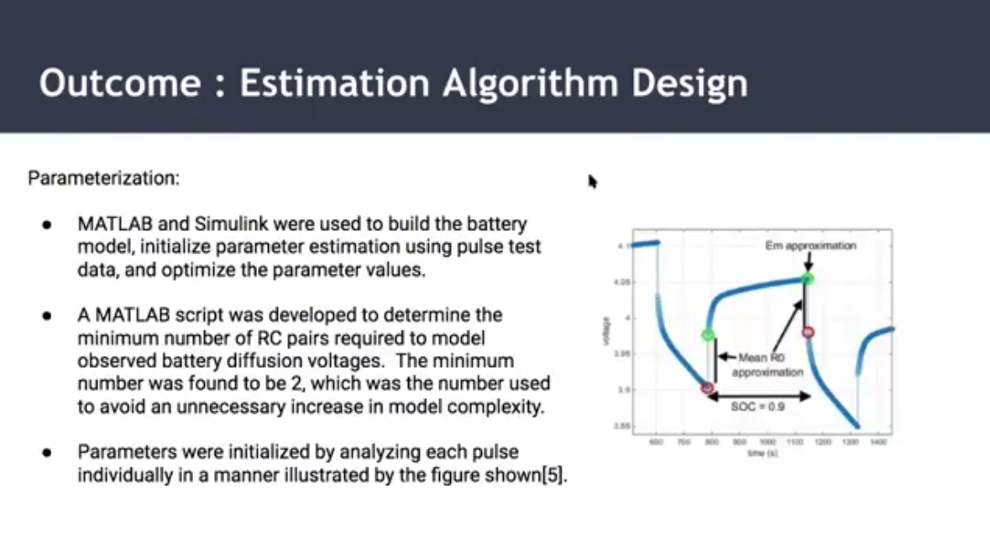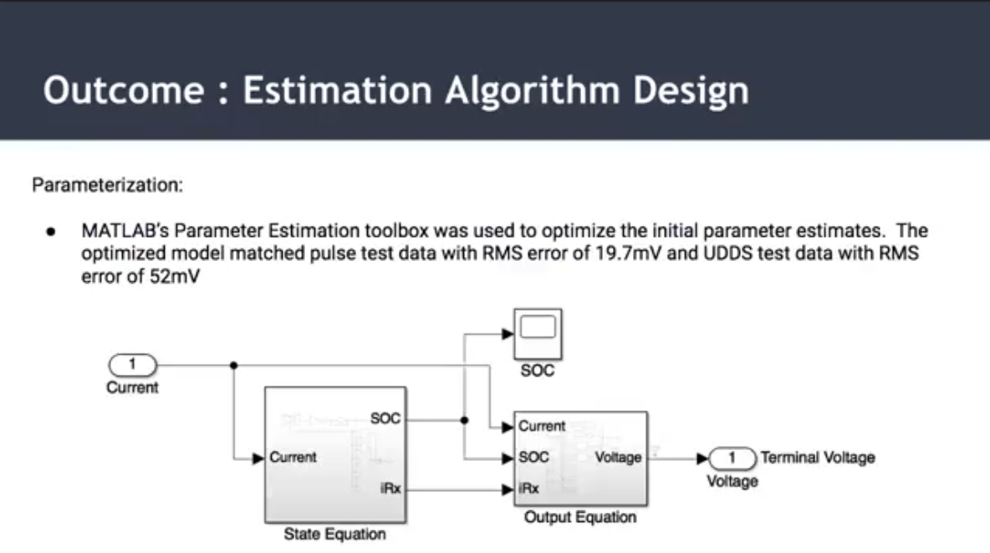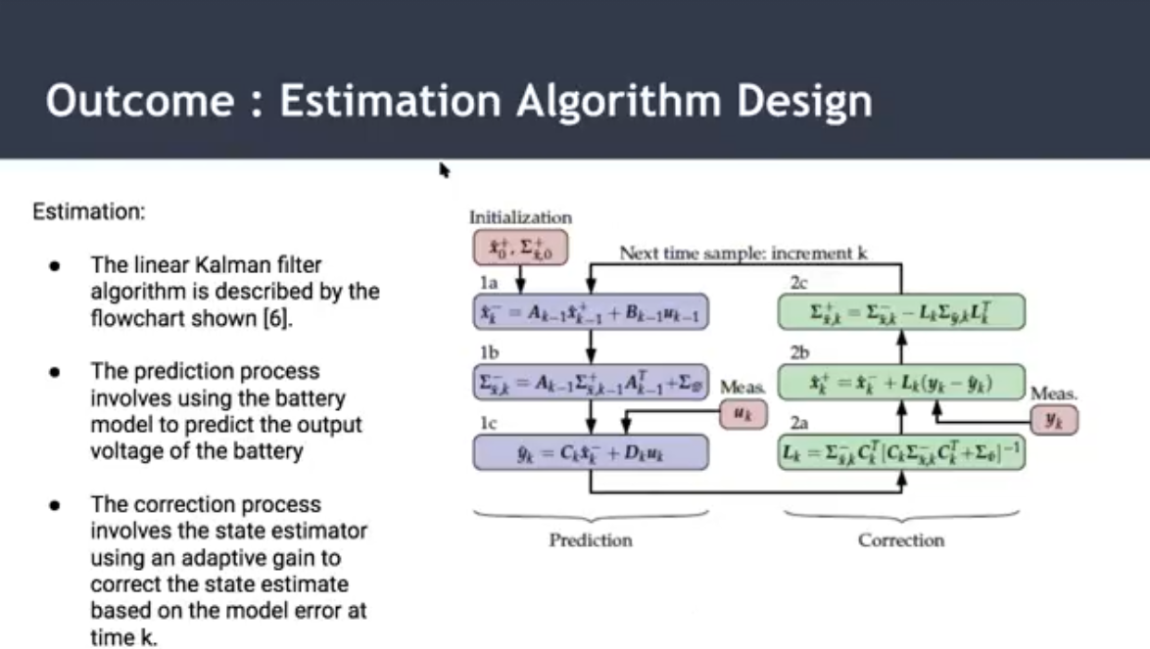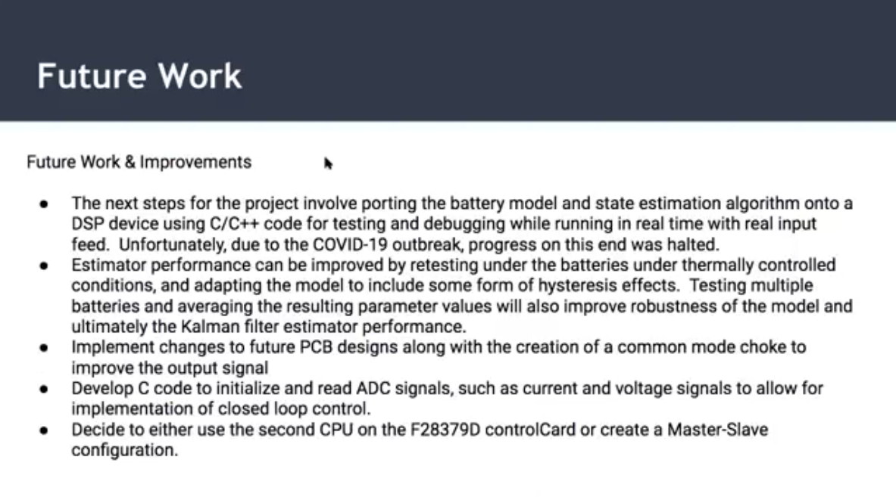

Plan:

* Understand the Kalman filter and write a skeleton code in Visual Studio (like Sarika and I did for the sorting algo)
* Test skeleton code with what data?
* <https://drive.google.com/drive/u/1/folders/1YgvoDtUlNdk-IT81HqU53rNpSdHIsQdh>
* <https://drive.google.com/drive/u/1/folders/1qPWwuN9FEXrEb-AZviUiD90Pydoa0wrH>
  + Can’t do real testing till current sense functionality is working, is this correct?
* Implement code into main DSP code in substitution for the random SOC generator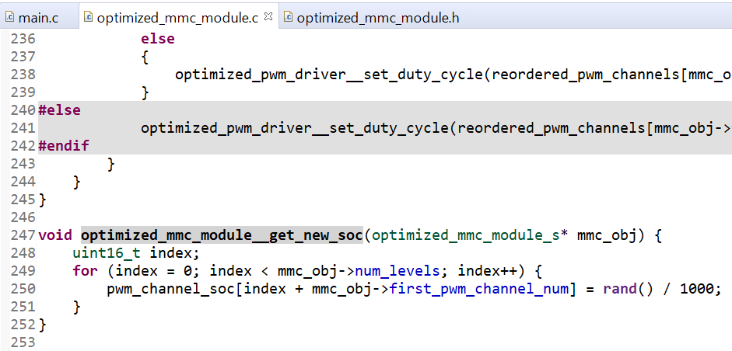

**To-Do:**

* Report & Presentation:
  + Adjust “IV. Embedded Systems (ES)” with
    - Sarika’s results
    - My code
  + Adjust “V. Future Work and Considerations”
  + Adjust “Conclusion” for (Report Only)
* Consolidate Information on Poster Board
  + 11/29: 7pm (Andrew / Jono)
  + 11/30: 8pm
  + 12/1: 8pm (Touch Up)